**PWS Population Impacted**

RESULTS

There are 41 PWS that have active surface water intakes. Out of these 90% would be impacted (37). The population served by these PWS is 899,872 relative to New Mexico’s 2019 population this represents 43% of New Mexicans drinking water is at risk with the loss in protection to their drinking water.

Calculation Steps

1. Add the following layers to the project

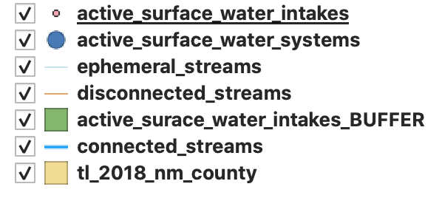

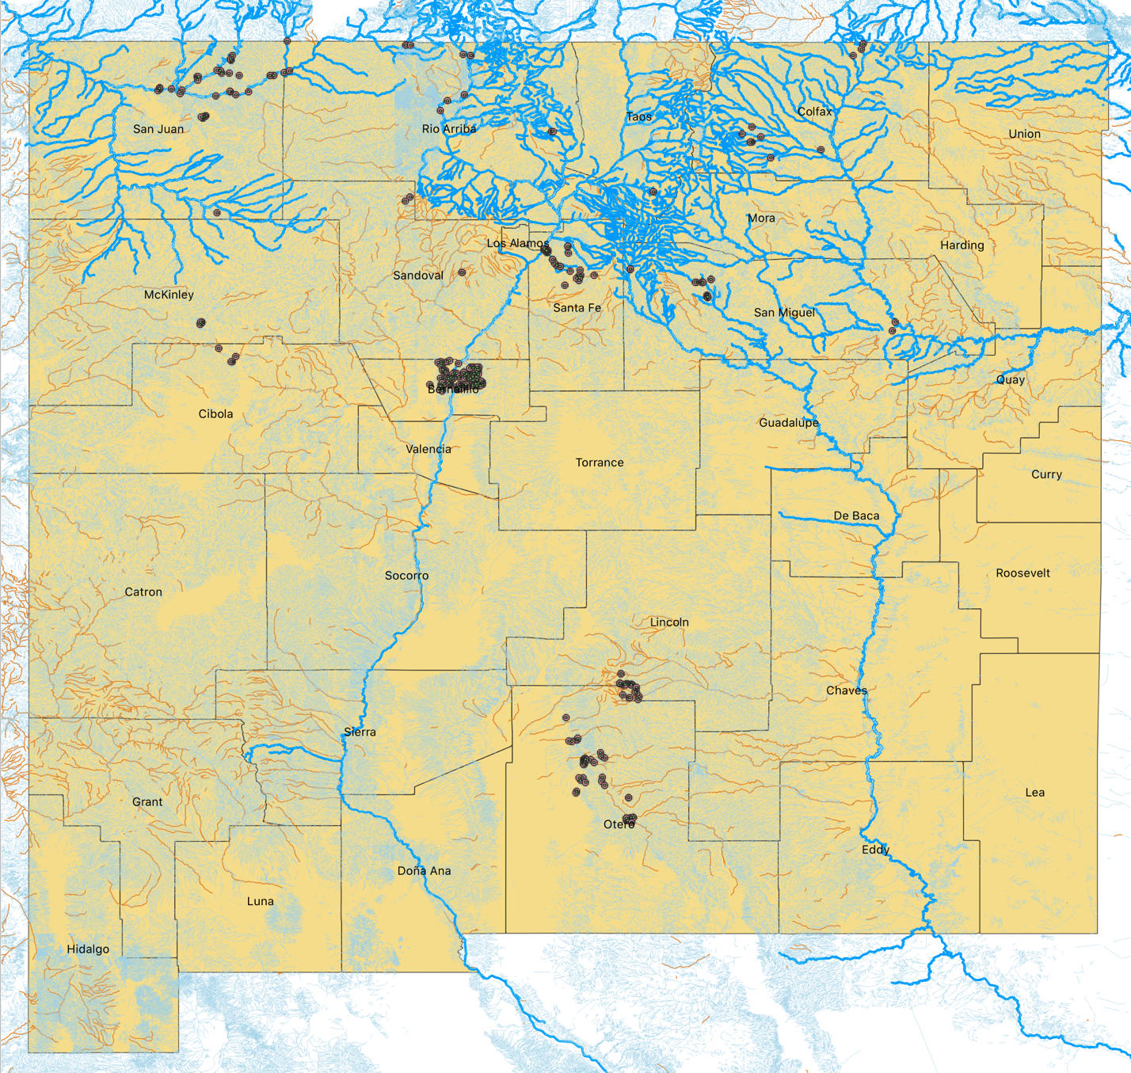

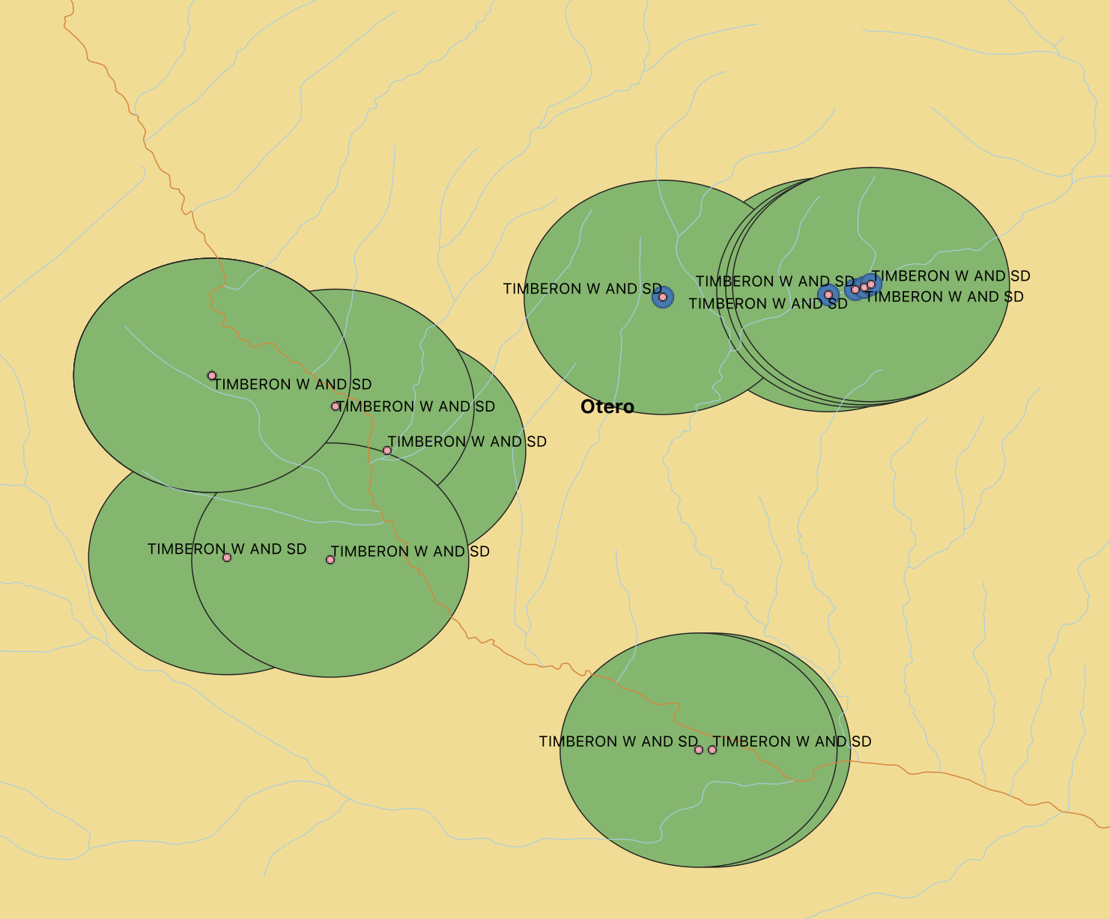

1. SELECT THE Buffers that intersect with an ephemeral stream

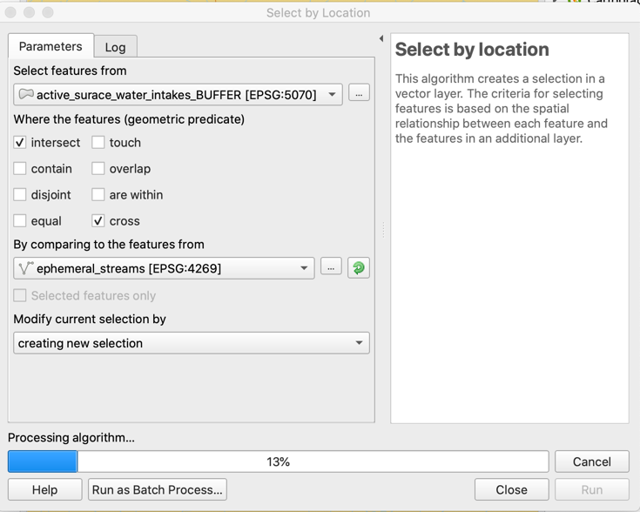

1. Add to selection the buffers that intersect with disconnected streams

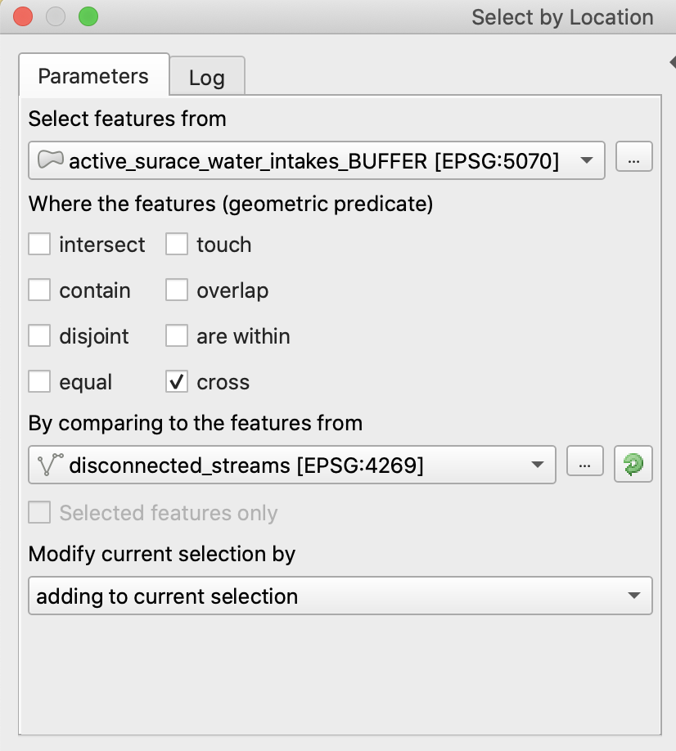

1. Create a new feature called “impact” that is equal to “1” if an ephemeral or disconnected river cross the buffer and equal to “0” otherwise.
2. Add the population served by the PWS that have any of their intakes impacted



**Questions:**

Gunnar: Noticed that the feature “Water_TYPE” for some of the active_surface_water_intakes was GU or GW instead of SW. Why can this be?